Team ID: PNT2022TMID01080
Assignment 4 :

Link of wokwi :
https://wokwi.com/projects/345863602171806292
Code and connections in wokwi for the ultrasonic sensor :

#include <LiquidCrystal.h>
const int trigpin = 13 ;
const int echopin = 12 ;
const int rs_pin = 4;
const int enable_pin = 15;
const int d4_pin = 5;
const int d5_pin = 18;
const int d6_pin = 21;
const int d7_pin = 22;
const int num_lines = 2;
const int num_columns = 10;
LiquidCrystal lcd(4,15,5,18,21,22);
#define sound_speed 0.034

long duration;
float distance;

void setup()
{
Serial.begin(115200);
pinMode(trigpin , OUTPUT);
pinMode(echopin , INPUT);
pinMode(rs_pin , OUTPUT);
pinMode(enable_pin, OUTPUT);
pinMode(d4_pin , OUTPUT);
pinMode(d5_pin , OUTPUT);
pinMode(d6_pin , OUTPUT);
pinMode(d7_pin , OUTPUT);
}

void loop()
{
digitalWrite(trigpin, LOW);
delayMicroseconds(10);
digitalWrite(trigpin, HIGH);
delayMicroseconds(10);
digitalWrite(rs_pin, HIGH);
delayMicroseconds(10);
digitalWrite(enable_pin, HIGH);
delayMicroseconds(10);
digitalWrite(d4_pin, HIGH);
delayMicroseconds(10);
digitalWrite(d5_pin, HIGH);
delayMicroseconds(10);
digitalWrite(d6_pin, HIGH);
delayMicroseconds(10);
digitalWrite(d7_pin, HIGH);
delayMicroseconds(10);

duration = pulseIn(echopin, HIGH);
distance = duration*sound_speed/2 ;
if (distance < 100)
{
lcd.begin(16, 2);
lcd.print("ALERT");
delayMicroseconds(3000);
Serial.println("distance"+String (distance)+"cm ALERT ");
}
else
{
lcd.begin(16, 2);
lcd.print("SAFE");
delayMicroseconds(3000);
Serial.println("distance"+String (distance)+"cm");
}
delay(10);
}

Result :

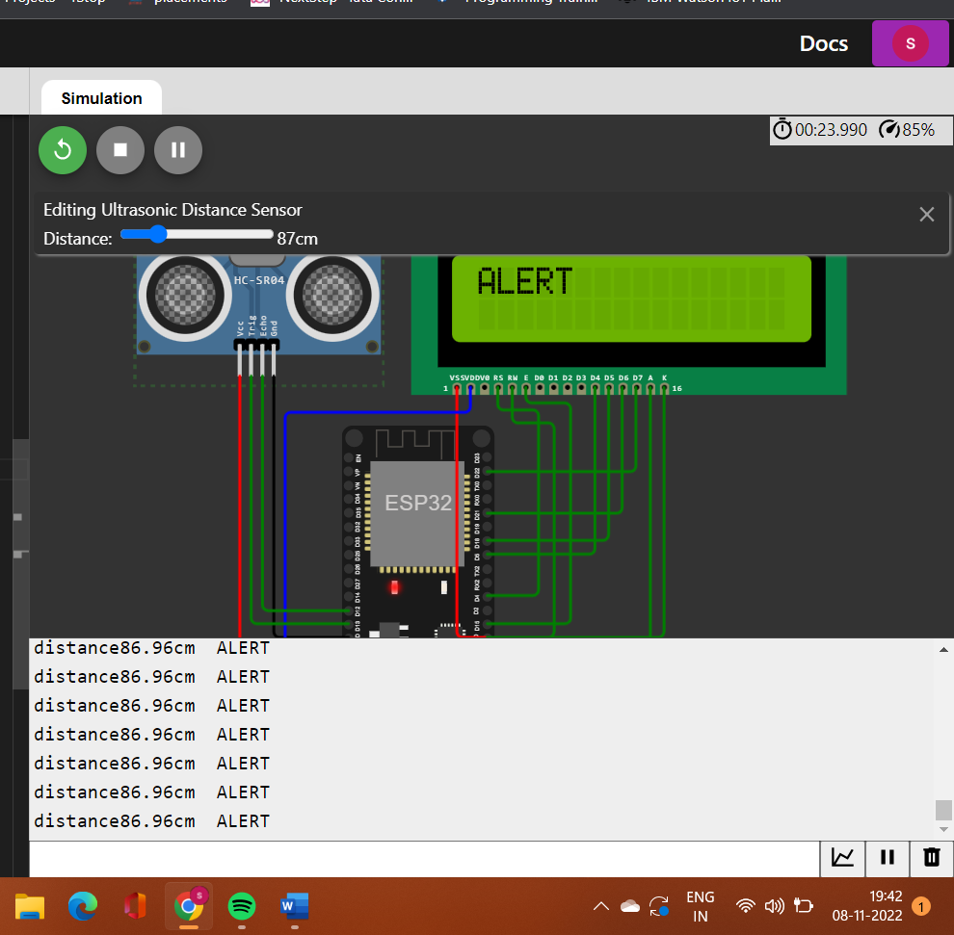
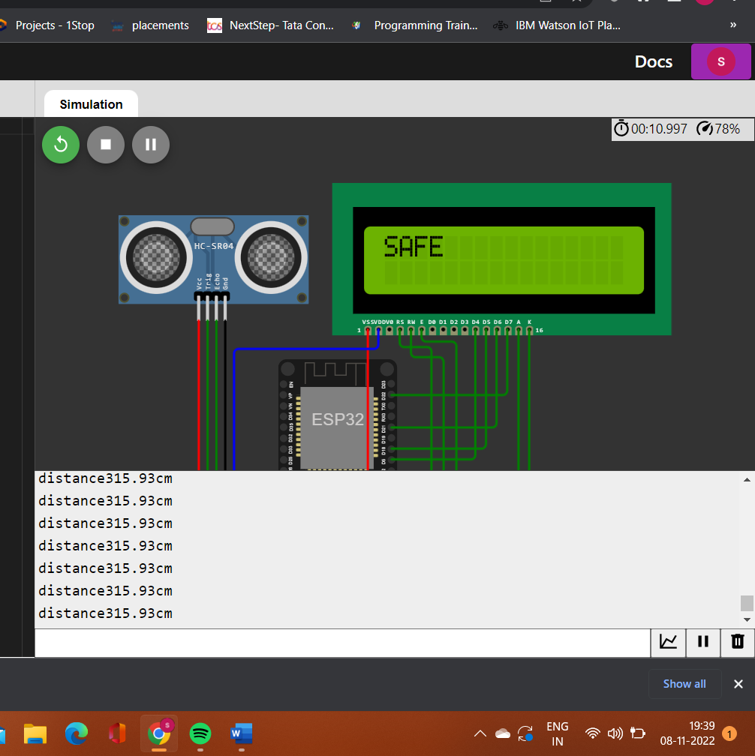

Image of IBM cloud output :

